Probability and Randomness Assignment
  - Module 3 - A03

Part One – Coding Warmup – Random Walkers and Bar Chart Bonanza (AKA the City)
- Code one of the following random walkers. You can use this code as a starting place if you’d like.

- A random walker with a 50% chance of moving in the direction of the mouse. The rest of the time it picks a random direction (up, down, left, right, and diagonals) with equal probability for all directions.
- A Gaussian walker where the step size (how far the walker moves in any given direction) is generated with a normal distribution.
- A random Perlin walker where the step size is used to move in a random direction is controlled by Perlin noise.
If you are coding a walker with a variable step size be sure to use a line to draw the steps.
Hard mode: Any of the above but with multiple random walkers moving around the same canvas. This should be implemented by way of an array of walkers.
- Write a p5js program that generates a random bar chart every second. The bar chart should be generated from the contents of an array of integers. Each second a new array of random integers should be generated. Your program will then loop through this array drawing a bar for each element. The height of each bar should be directly related to the integer stored in the associated array element. I realize the array isn’t really needed to code this, but I wanted to give you a bit more array practice. :)

Your sketch output might look something like this gif.

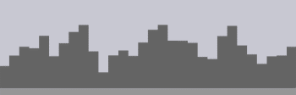
Hard mode: If bar charts feel boring, constrain heights such that what you generate looks like a city skyline. Maybe add some windows too, where some windows have lights on and others don’t?
Requirements:
  - Array size should be 10 or greater. (And therefore the number of bars in your bar chart be of the same number.)
  - A new collection of random numbers should be generated for every new bar chart.
  - Random integers should be in a specified range. This could be from zero to 100, or something more specific for the city challenge.
  - 1 second delay between each random bar chart.
  - Colour of bar and background are up to you.

Part Two – Drawing With Chaos
It’s time to get creative and draw a picture using randomness and noise in a p5js sketch! Every time you run your sketch a slightly different picture should be generated.
Some suggestions:
- You might generate a map, a landscape, a weird creature, a still-life, abstract art. You name it!
- 1D Perlin noise can be used to draw waves and mountains.
- 2D Perlin noise can be used to draw clouds, or the texture of rocks.
- Randomness can be used to place lines, shapes, and image sprites within a scene.
- Random walkers can be used to paint abstract art.
- Colours can be selected by randomizing red, green, and blue values to the color() function. (But a nice colour pallet is a lovely thing!)
For inspiration read this Fast Company article on The Value of Randomness in Art and Design.
Be sure to use random(), noise(), and gaussianRandom(). Or you could create three sketches, one for each of these functions.
For an added challenge you could make your drawing change over time rather than creating a static image.
Along with your sketch please submit a short reflection in a comment block explaining what you originally intended to create, how the end result differed from this intention, and what problems/discoveries you encountered along the way.
Here’s some inspiration. Feel free to attempt to recreate these images with your own code:
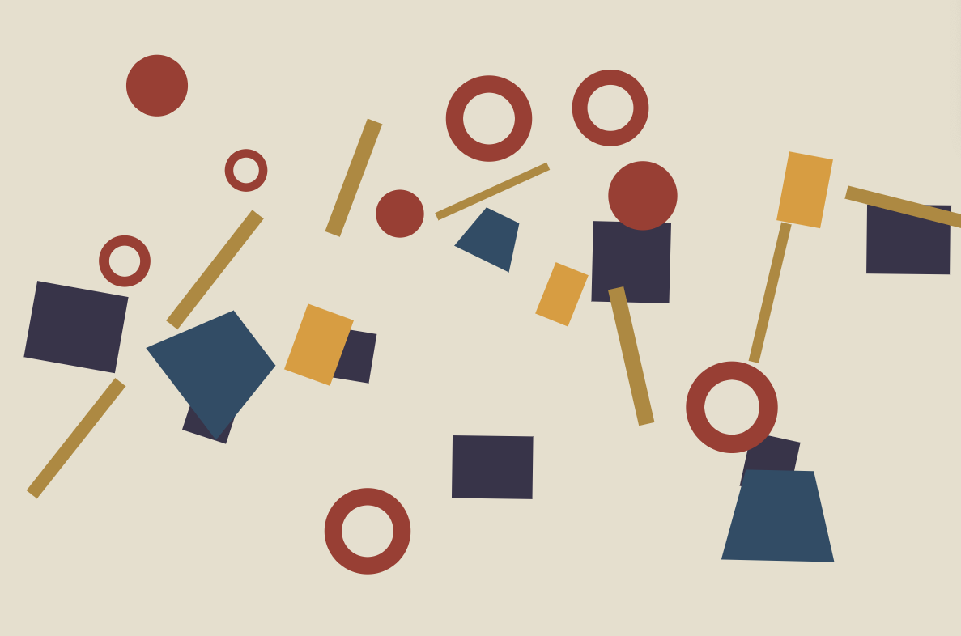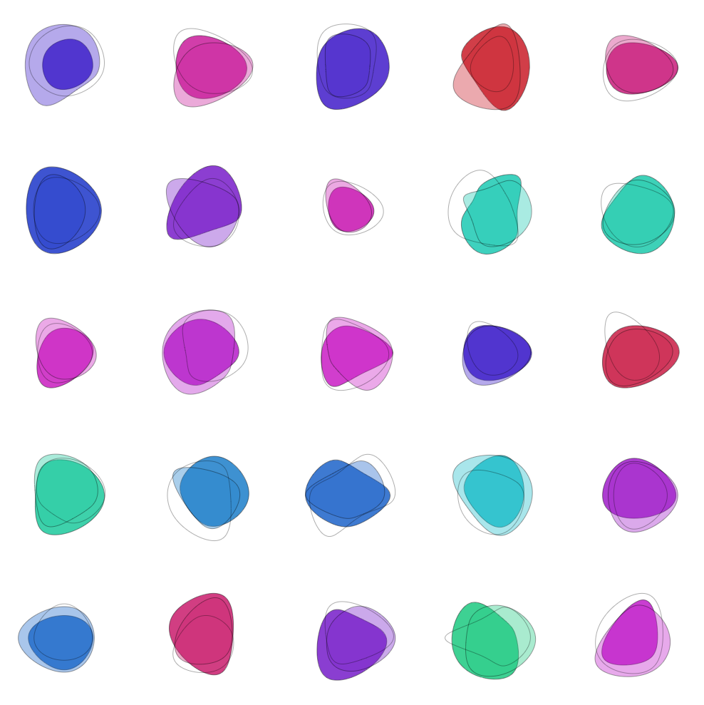
 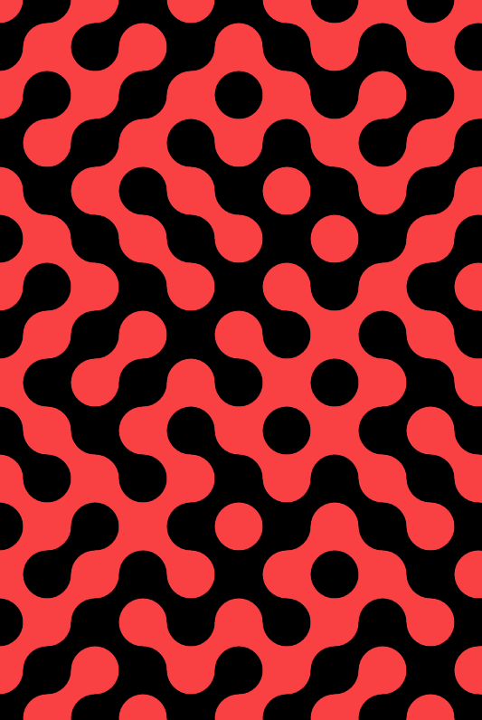 
Images found online. Appologies to the artists for the lack of attribution. I wasn’t dilligent about saving the source URLs.

Requirements

Part One

Coding Warmup – a) Random Walker
- There’s a comment in your code that specifies which of the three random walkers you chose to implement.
- You correctly implemented your selected random walker based on the question text.

Coding Warmup – b) Bar Chart Bonanza
- Your sketch generates a new random bar chart every second.
- Your sketch conforms to all of the required details listed in point form below the question text.

Part Two

Generative Drawing Code
- You’ve generated one or more drawing that make use of randomness and noise.
- Your sketch(s) make(s) use of the random(), noise(), and gaussianRandom() functions.
- Each time you run your sketch(s) a different drawing is produced.
- Your sketch includes a short reflection written in a comment block.

Generative Drawing Reflection
- Your reflection includes commentary on:
  - What you originally intended to create.
  - How the end result differed from this intention.
  - What problems and/or discoveries you encountered along the way.

Part One and Two: Coding Conventions
- A block comment is included at the top of all source file, along with your name.
  - For sketch.js this block includes a description of the program and the classes involved (if any).
  - For other js class files this block includes a description of the class.
- All your source code is nicely formatted and is easy to read.
- All nested code is consistently indented using exactly 2 spaces.
- All variables are named descriptively using camel case.
- All magic numbers have been converted to constants or method/function parameters.
- Complicated portions of your code are accompanied by comments that provide context and explanations.
- Your comments are written in full sentences with proper spelling, grammar, and punctuation.

Marking Rubric
Assignment Requirements | Point Scale = 3 | Point Scale = 2 | Point Scale = 1 | Point Scale = 0 | Weight | Score Earned
Part One  a) Random Walker | Your sketch confirms to all the point from the requirements listed above, including the “hard mode” requirement. | Your sketch confirms to all the point from the requirements listed above but does not implement the “hard mode” requirement. | Your sketch is missing one or more of the above listed requirements. | Your sketch was not submitted, is missing most of the listed requirements, or runs with an error that prevent the output of the random walker. | 1 | /3
Part One  b) Bar Chart Bonanza | NA | Your sketch confirms to all the point from the requirements listed above. | Your sketch is missing one or more of the above listed requirements. | Your sketch was not submitted, is missing most of the listed requirements, or runs with an error that prevent the output of the bar charts. | 2 | /4
Part Two – Generative Art | The three types of randomness you’ve employed match the needs of your drawing well. Your sketch(s) produce(s) complex, interesting, and beautiful results. | Your generative drawing(s) run(s) without error and produce(s) a new image with each run. Your drawing(s) use all three forms of required randomness. | Your generative drawing(s) run(s) without error and produce(s) a new image with each run. Your code does not make use of all three forms of required randomness. | You did not complete the generative art portion of the assignment, or your code runs with an error preventing the output of an image. | 3 | /9
Part Three – Reflection |  | Your code includes a reflection within a comment block, that meets all the “Generative Drawing Reflection” requirements. | Your code includes a reflection within a comment block, but the reflection is missing one of the “Generative Drawing Reflection” requirements. | Your code does not include a reflection within a comment block, or the reflection makes little sense due to poor spelling or grammar. | 1 | /2
Parts One & Two -Coding Conventions | Code organization or structure needs improvement. Many “coding convention” requirements are not met for two or more of your sketches. | Code organization or structure needs improvement. Many “coding convention” requirements are not met for one of your sketches. | Adequate code organization and structure. One or more “coding convention” requirement is not met for one of your sketches. | Exemplary code organization/structure that conforms to all stated “coding convention” requirements. | -1

Total Earned Out of 18:

